

RESPONSE TO TfL PUBLIC CONSULTATION
ON PROPOSED SUPERLOOP ROUTE SL11
NORTH GREENWICH---ABBEY WOOD

Future Transport London campaigns in favour of public transport use and active travel and against the unnecessary use of private cars.

We have responded formally in favour of earlier Superloop consultations and are now responding generally in favour of the proposed Superloop route SL11 as planned: to replace 24-hour route 472 with a limited stop service except overnight (when route N472 will operate as route 472 does now).

We hope that the SL11 scheme will attract more people to public transport, compared with the existing route 472 operation, by reducing journey times, especially between Thamesmead and: Abbey Wood station, Woolwich Town Centre, Charlton station and North Greenwich station. We make a case for it also to serve the “Warspite Road” stops in Woolwich Church Street for the Morris Walk Estate, which has just been redeveloped at high density.

We note that the proposed bus SL11 follows a very similar route to that proposed for the 16km, segregated Greenwich Waterfront Transit (GWT) scheme on which LT/TfL consulted the public one quarter of a century ago, but (apart from the 1.6km Millennium Busway) GWT was never implemented, in spite of a very favourable public response to that consultation and most of the erstwhile Millennium Busway has since been converted to standard bus lanes.

Does TfL no longer recognise the benefits of segregation (including reduced journey times and improved reliability compared with ordinary bus lanes) for all bus routes operating along a segregated corridor?

Are no new bus priorities proposed in connection with route SL11? None are mentioned in the consultation information. Shouldn’t TfL be trying to improve the current very slow average bus speeds in London by any means at its disposal?

The introduction of the SL11 is a good time to ensure there are bus lanes (probably part-time ones) on the dual carriageway stretch of Anchor & Hope Lane, Charlton and Bugsby’s Way, Charlton between the Anchor & Hope and Peartree Way roundabouts. Bus times can be severely affected by heavy traffic principally caused by the car-dominated retail outlets throughout West Charlton Riverside and before/after Charlton Athletic football matches.

Charlton station interchange and the Antigallican junction

The proposed SL11 bus stops nearest Charlton station are about 300 metres from the trains and across busy carriageways, providing very poor bus/rail interchange indeed (it is also far from exemplary at Plumstead station; at Woolwich Arsenal station, it will be worse than currently provided by route 472).

We suggest instead that North Greenwich bound SL11 services call at stop H, immediately outside Charlton station by using the dedicated bus turnaround there, that any delays are tackled by making the left turn, from Woolwich Road into Charlton Church Lane at the Antigallican junction, bus and taxi only; and that the traffic lights are phased to ensure bus priority.

The 486 is currently the only bus swerving Charlton station directly and is quite unreliable, this is a major junction and currently passengers must undertake the dance of death to reach the nearest bus stops (in Anchor & Hope Lane and Woolwich Road) due to very unsatisfactory nature of this junction. It should be a clear interchange immediately next to the station rather than a difficult walk, especially for those with impairments. This is all about mode interchangeability and pedestrian safety.

Woolwich and Woolwich Arsenal stations interchange

If bus/rail interchange at Charlton station can be improved as suggested above, it will be much more acceptable having bus SL11 call only once in each direction in Woolwich Town Centre (at “Woolwich station”) contributing to reduced journey times for through bus passengers.

However, we note that route SL11 is proposed to operate nonstop between Charlton and Woolwich stations, bypassing (eastbound) no fewer than eleven existing route 472 stops (although they would continue to be served by other bus routes).

Warspite Road and the Morris Walk Estate

Bus SL11 is NOT currently planned to serve the “Warspite Road” stops (one in each direction) on Woolwich Church Street at the north side of the Morris Walk Estate, which has been rebuilt at high density: new residents started moving in at the beginning of 2025.

While route 380 serves the south side of the Morris Walk Estate, we would ask TfL to consider having bus SL11 call at “Warspite Road” to maximise public transport access from the north side of Morris Walk Estate and to discourage new residents from feeling they need to have a car.

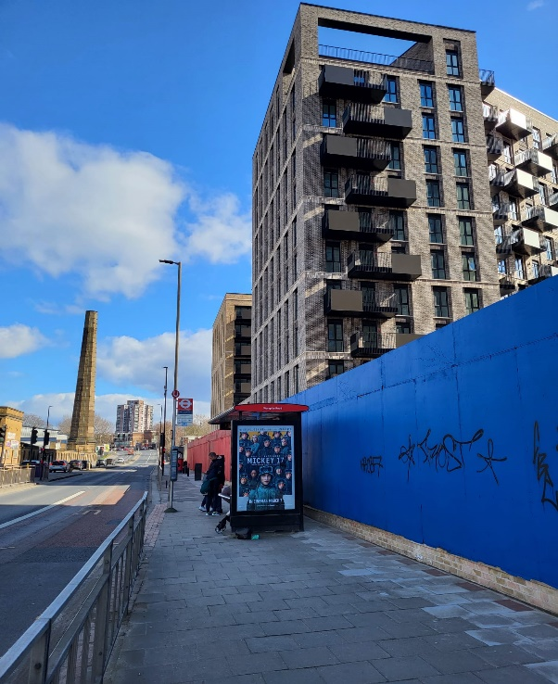

Foreground: The westbound Warspite Road bus stop, on Woolwich Church Street, is so close to the new tower blocks on the Morris Walk Estate and likely to become very busy when all those flats are occupied, justifying a call by buses on route SL11 (if only on a request basis). The eastbound bus stop is on the other side of the road, just beyond the controlled crossing.

We hope these comments are helpful.

